**WEARDA software package**

**for wearable to monitor activity of people**

**Richard van Dijk - Daniela Gawehns - Renelle Bourdage**

Leiden University,

Faculty of Math and Natural Sciences,

Leiden Institute of Advanced Computing Science,

The Netherlands

Email: m.k.van.dijk@liacs.leidenuniv.nl

May 17, 2021

**Abstract** We present the Wearable Sensor Data Acquisition WEARDA software package for acquisition of data from wearable devices. This software package was initially created for the Dementia project “Dementia back at the heart of the community” [0] running between 2018 and 2022 in a cooperation between Netherlands Institute for Health Services Research (NIVEL) Utrecht and Leiden Institute of Advanced Computer Science (LIACS), University of Leiden. This project aims to assess how changes in the environment from a traditional, closed setting (I.e., residents cannot leave the care home unaccompanied) to an open setting (resident can leave the care home, but are monitored) affect residents, staff, family members and visitors of the nursing home and adjacent park. A Tizen Smartwatch[1] was chosen because of its relatively open operating system and acceptance by research participants. The wearable monitored resident’s activities by recording acceleration (tri-axis accelerometer), rotation velocity (tri-axis gyroscope), outdoor location trajectory (Global Positioning System) and floor (barometer). Privacy rules were applied by use of a predefined privacy circle based on GPS coordinates. Recordings are labeled as outside the privacy circle whenever the watch left the pre-defined area.

**Keywords** Smart watch - Tizen OS - Tri-axes accelerometer - Tri-axis gyroscope - GPS - Privacy circle.

**1 Introduction**

The project "Dementia at the heart of the community" was initiated in 2018 as a cooperation between NIVEL Utrecht and LIACS, University of Leiden. One of the objectives is to study activity patterns of people living with Dementia. To monitor activity, the project selected the Samsung Gear Fit Pro 2, a digital watch issued in 2016. This watch includes accelerometer, gyroscope, barometer, and GPS (Global Positioning System) sensors. In this paper, we present the software used to enter patient identifiers, record sensor values in files, save the measurement settings (meta data) and activate the privacy circle. The Tizen organization [2] offers the Tizen Studio software environment free of charge to design applications and services for the watch. Many programming examples and excellent API documentation are available online.

**2 WEARDA software package**

We developed the WEARDA software package, consisting of two main components: an interactive application that can be operated through the touchscreen, and a data collection service that runs in the background.

*2.1 Sensor application*

The software package contains the Tizen OS widget application “liacs.sensorapplication” visible in the list of applications with as title “Sensors” and a digital brain as icon. It is meant for the researcher. The application carries a spinner entry widget control to enter the person id, a number between 000 and 999, and two buttons: the RESTART button to start or restart measurements and the CLEAN button to remove all measurements from the watch. It needs to be pressed 3x to prevent unintended removal when pressing the button accidentally. The application can be closed by pressing the back button on the side of the watch. This will not influence the measurements but allows the participant to use other applications on the watch or switch to another watch face. We did not supply a STOP button because of the fear that participants would press this button. The measurements can only be stopped by shutdown of the watch. In the data collection scenario, once a measurement period is over, the watch gets shutdown and re-charged before the data is downloaded and the watch used for the next participant. Shutting the watch down reduces power consumption, thus the charge duration will be shortened for the next experiment to start. In laboratory experiments, the person id can be used as an identifier within a fixed data collection protocol. For example if different types of daily activities such as washing dishes, cutting vegetables or biking are performed in an controlled environment (e.g., ID 001 = washing dishes, 002 = cutting vegetables, et cetera).

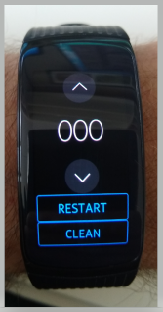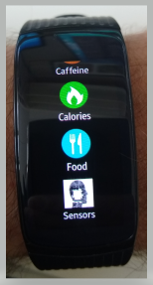

Fig 1, Left: the icon of the sensor application in the Tizen OS menu, right the sensor application with the person id snipper, restart, and clean button.

The measurement records are stored in comma separated values sensor files and the file name contains the person id, date, time, watch id and sensor types. This information also appears in the first line of these files. The experimenter retrieves the files are retrieved by use of the Smart Development Bridge (SDB), a command line tool which is part of the Tizen Studio package. It is advised to retrieve the files daily while collecting data to validate the data in the evening and not losing data because wearables can get lost or damaged. In principle, the watch can store 0.5 GB of data enough for 7 days of measurements 12 hours a day. Which means that longer, free living data collection at home is possible and only limited by the battery power of the watch.

Sensors can be recorded at different frequencies. For every readout frequency, a separate file is created. In that way less frequent value changes do no need to be recorded many times while not changing along high frequent value changes. This reduces power consumption and memory usage because this measure will reduce the number and size of recordings. Sensor values are stored in the comma separated value file format.

The application contains one central clock which is used for all recordings so the scattered data storage can be aligned with one time reference. It is advised to synchronize the time of the watches before the data collection. Precise time synchronization can be established automatically by connection to the internet via Bluetooth or WIFI. The motion sensors are usually read out with high frequency 25-50Hz, while the barometer, battery, and GPS (Global Positioning System) have lower frequencies 0.25 – 2Hz.

The data collection is configured via a configuration file which is pushed to the watch in an application independent accessible file system directory. Its contents, together with the software package version, is copied to a meta file in text format as part of the sensor files generated by each series of measurements to keep track of the settings used for each measurement. We choose a configuration with configuration files as those can be designed once and batch processed on all watches in a reasonable time frame. The batch processing makes the configuration less prone to errors. Once a configuration file is designed, it can be uploaded to the watches with the SDB command line tool.

*2.2 Sensor service*

The software package contains an Tizen OS widget service “liacs.sensorservice” which runs in the background, neither visible in the list of applications nor visible via the display of the wearable. This design makes continuous measurements possible since Tizen applications become idle after brief time to reduce power consumption of the display while services become idle if the battery is almost empty.

The sensor service processes the messages RESTART and CLEAN sent by the sensor application. After start of the watch, the sensor service is activated and waiting for these messages. After one valid message is received, the service starts the recording of the sensor values and stores it into comma separated values files. The measurement is based on the contents of the uploaded configuration file.

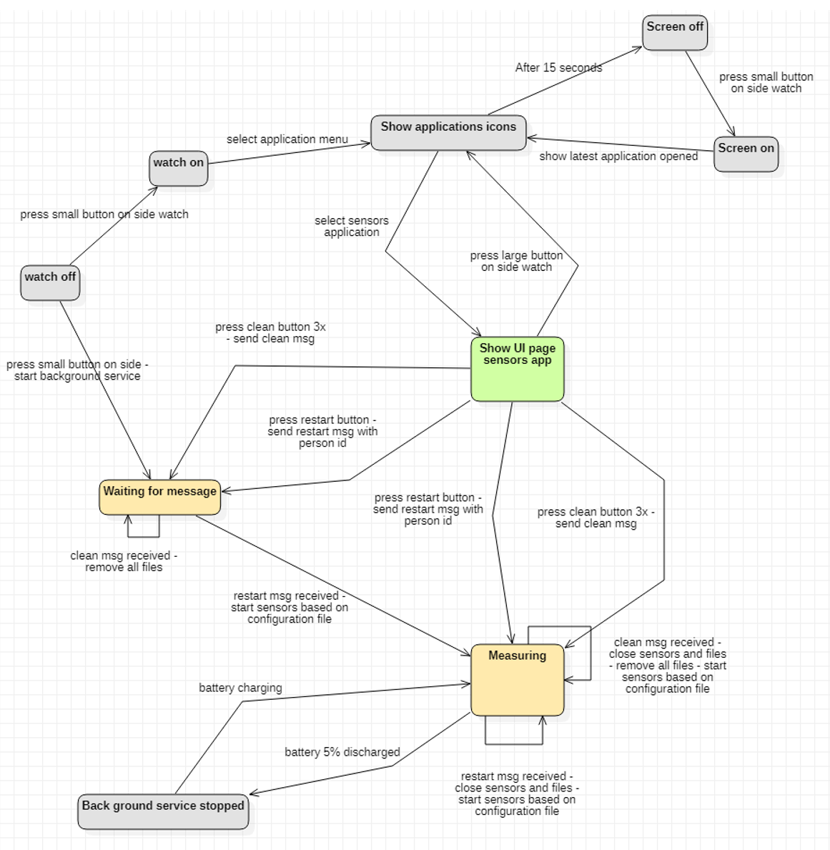

Fig 2, State diagram of sensor application (green), sensor service (orange) and the Tizen OS (grey).

Above figure shows a state diagram with transitions with format “event - actions”, as a formal description of the states and relevant state events between the watch application manager, the sensor application and service.

**3 Statement of testing**

The software package WEARDA embeds data collection experiences in the field to monitor activities of persons. It contains a person identifier input capability per measurement, a configuration file to be used as meta file next to the raw data. It contains a unique device identifier to trace back measurements to a specific wearable so that typical variances in sensors can be taken care of. The duration of measurement is enlarged to 3.5 hours with GPS use and 8 to 12 hours without GPS. The sample density is optimized to > 90%. The sample density is the ratio between recorded samples divided by the expected number of samples.

Typically, by time sliced operating systems, a strict timing regiment of reading out sensors with a configured sample frequency is hard to implement. The package contains a write timer to write sensor values to the sensor files in its own pace and a duplication removal functionality. The best timing intervals for the write timer and read out of the sensors frequently are listed below.

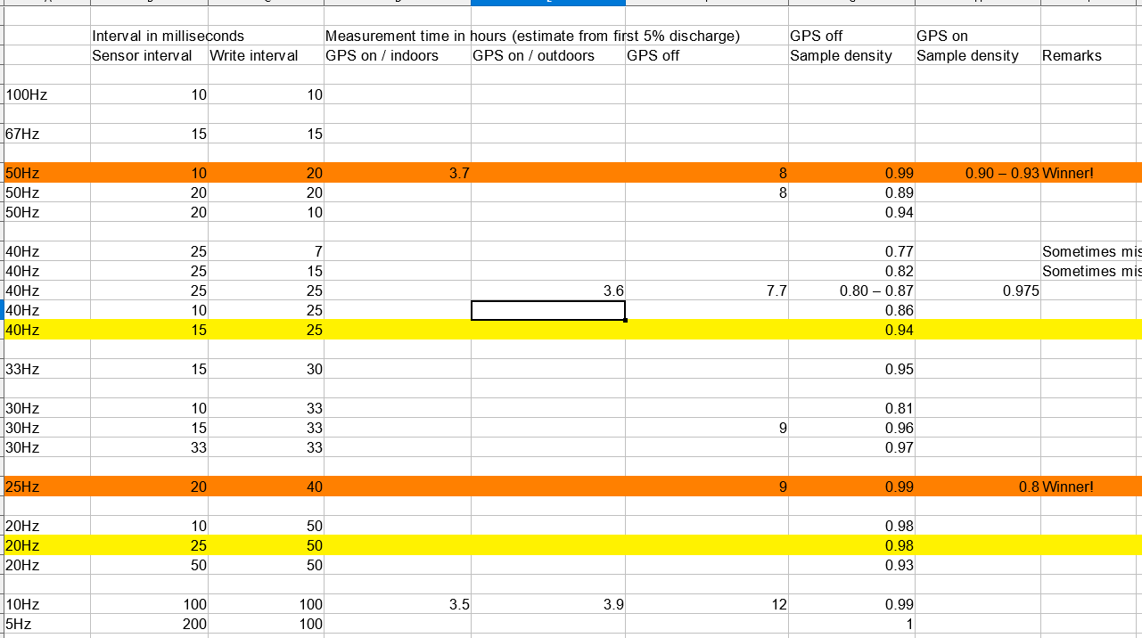

Fig 7, Sample density and measurement duration dependent on interval readouts.

The wearable was manually tested. We conducted a spinning test – watch rotating on its Gorilla glass - to validate the values of the accelerometer and gyroscope sensors. The sensors position was outside the center of the watch rotation.

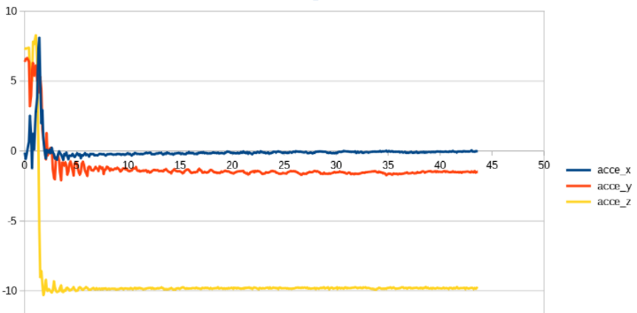

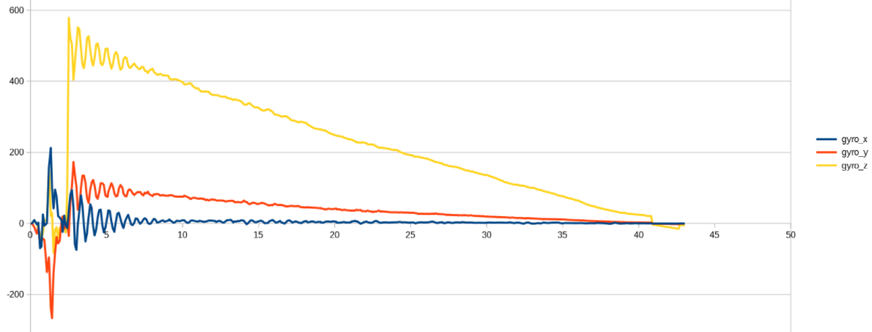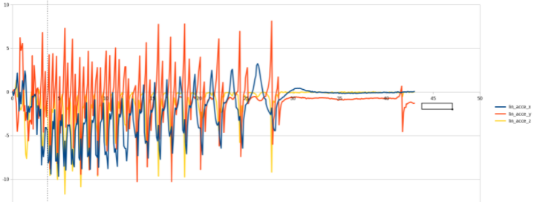

*Fig 3, Watch spinning on its glass, decelerating. The oscillation is caused by the movements of the arms of the band. The top graph shows the gravity acceleration in m/s^2, the middle graph the linear acceleration in m/s^2 and the bottom graph the rotation velocity not converted to SI basic units. The horizontal axis of all graphs is the time in seconds.*

The gyroscope values showed a decreasing trend on two of its axes, the acceleration values showed ax = 0, ay around 1.2 m/s^2, az around 9.8 m/s^2. The linear acceleration was not valid for high rotation velocities but showed promising values after 32 seconds. The linear acceleration is derived from the gravity acceleration with an algorithm used by Samsung.

Zero measurements showed an amount of variance of the acceleration values within a range of 0.15 - 0.25 m/s^2, see the normal distribution below of the gravity acceleration vector G and a figure with the average and standard deviation of G of several watches.

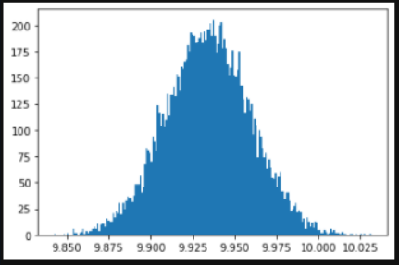

Fig 4, Zero measurement of gravity acceleration vector norm G results in a normal distribution as shown, G = sqrt (ax^2 + ay^2 + az^2).

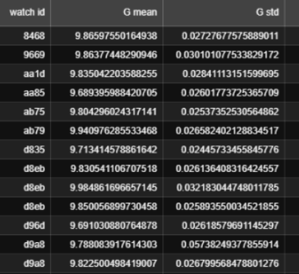

Fig 5, Average and standard deviation of G of several watches.

The barometer and GPS were validated by comparing height differences of a GPS track with the air pressure measured [3]. An air pressure difference of 1 milli bar (hPa) corresponded to 7,75 meters at sea level, temperature 10 degrees Celsius. The accuracy of the barometer is 0.01 milli Bar (0,075 meters).

It is advised to calibrate the sensor values and convert them to SI basic units before further processing to be capable to reproduce analysis conclusions compared to studies done with other sensors.

**4 Statement of re-use**

While developed for the Dementia project of LIACS and Nivel, the WEARDA package was designed in a generic manner to allow reuse in other contexts. The package can be reused with minor reconfiguration for any project where another wearable device running the Tizen OS is used for collecting activity information. Items to be configured include the coordinates and radius of the privacy circle, selection of the sensors and the polling frequency appropriate for the type of sensor being used, see below an overview of all settings.

|  |  |  |
| --- | --- | --- |
| **Field name** | **Field type** | **Possible values, ( ) = default** |
| **Unique identifier watch** | string | Example "D8F8" |
| **Accelerometer interval** | integer | 0 indicates switched off  10 – 1000 (25) milliseconds |
| **Linear accelerometer interval** | integer | 0 indicates switched off  10 – 1000 (25) milliseconds |
| **Gyroscope interval** | integer | 0 indicates switched off  10 – 1000 (25) milliseconds |
| **Barometer interval** | integer | 0 indicates switched off  100 – 10000 (100) milliseconds |
| **GPS interval** | integer | 1 – 10 (1) seconds |
| **GPS base point privacy circle, latitude** | float | -90.0 – 90.0 (52.169311) degrees |
| **GPS base point privacy circle, longitude** | float | -180.0 - 180.0 (4.456711) degrees |
| **GPS base point distance to privacy circle edge** | integer | 0 indicates switched off  10 – 10000 (100) meter |
| **Write interval** | float | 0.01 - 10.0 (0.05) seconds |

*Fig 6, Configuration items.*

For projects where similar wearables are used (i.e., smart watches with a comparable set of sensors), the overall architecture of the WEARDA package is reusable, as are the optimization strategies for energy consumption, time synchronization, robustness of the measurement and logging the data.

The wearable chosen meets the requirements set out in 2018. The development of wearables continued and there will be better alternatives available in terms of battery discharge / charge duration, quality of the sensors and software development environments such as Wear OS of Google.

Google and the Tizen foundation recently decided to merge both their operating systems Wear OS and Tizen OS into a new OS called "Wear" [4]. This means that our application can also run-on Wear OS wearables in the future possibly with little adaption.

**Data policy**

The data collection of the Dementia project of LIACS and Nivel will be available to other researchers but not to the general public because of their privacy sensitive nature.

**Acknowledgements**

We acknowledge contributions from Jeremie Gobeil and Joost Visser members of the LIACS Software Lab, during the genesis of this project. This work is partly financed by ZonMw, under project number 733050846, the hours of the LIACS Software Lab were financed by LIACS, the Leiden Institute of Advanced Computer Science.

**References**

[0] Dementia back at the heart of the community,

<https://www.universiteitleiden.nl/en/research/research-projects/data-science-research-programme/data-science-research-programme-project-daniela-gawehns>

[https://europepmc.org/grantfinder/grantdetails?query=pi%3A%22van%20Beek%2BS.%22%2Bgid%3A%22733050846%22%2Bga%3A%22ZonMw%22](https://europepmc.org/grantfinder/grantdetails?query=pi%253A%2522van%2520Beek%252BS.%2522%252Bgid%253A%2522733050846%2522%252Bga%253A%2522ZonMw%2522)

[1] Samsung Gear Fit Pro 2 manual / official specs,

<https://www.samsung.com/us/business/support/owners/product/gear-fit2-pro-bluetooth/>

[2] Tizen Foundation organization,

<https://www.tizen.org/>

[3] GPSVisualizer, GPS website by Adam Schneider, Portland, Oregon, United States,

<https://www.gpsvisualizer.com/>

[4] Merge of Wear OS and Tizen,

<https://www.theverge.com/2021/5/19/22443809/google-samsung-wear-os-tizen-things-we-know>